**Networking and system administration lab**

**MOTHER BOARD:**

A **motherboard** (also called **mainboard**, main **circuit board**,[[1]](https://en.wikipedia.org/wiki/Motherboard" \l "cite_note-Engadget-1) or **mobo**) is the main [printed circuit board](https://en.wikipedia.org/wiki/Printed_circuit_board) (PCB) in general-purpose computers and other expandable systems. It holds and allows communication between many of the crucial electronic components of a system, such as the [central processing unit](https://en.wikipedia.org/wiki/Central_processing_unit) (CPU) and [memory](https://en.wikipedia.org/wiki/Computer_memory), and provides connectors for other [peripherals](https://en.wikipedia.org/wiki/Peripherals). Unlike a [backplane](https://en.wikipedia.org/wiki/Backplane), a motherboard usually contains significant sub-systems, such as the central processor, the [chipset](https://en.wikipedia.org/wiki/Chipset)'s [input/output](https://en.wikipedia.org/wiki/Input/output) and memory controllers, [interface](https://en.wikipedia.org/wiki/Interface_(computing)) connectors, and other components integrated for general use.

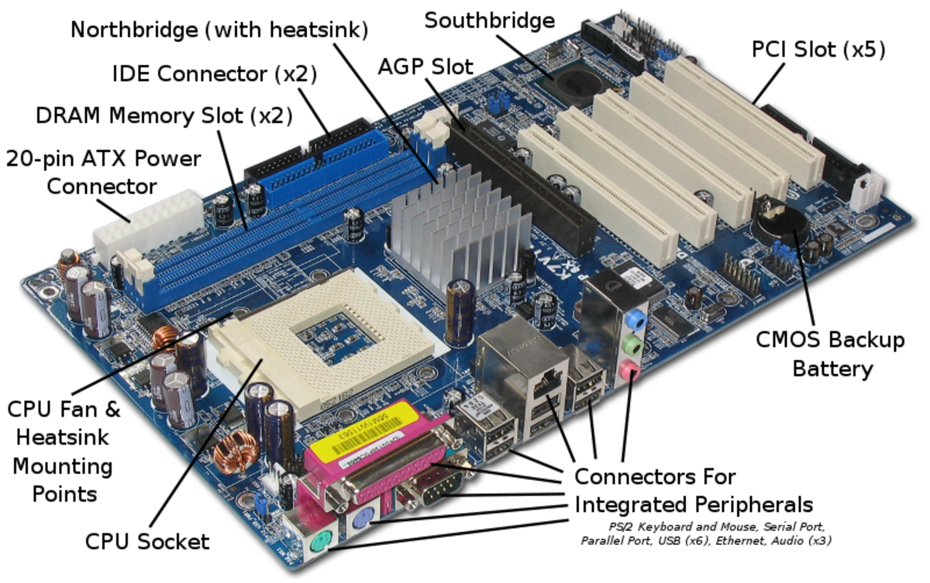

**RAM MODULE:**

In [computing](https://en.wikipedia.org/wiki/Computing), a **memory module** or **RAM (**[**random-access memory**](https://en.wikipedia.org/wiki/Random-access_memory)**) stick** is a [printed circuit board](https://en.wikipedia.org/wiki/Printed_circuit_board) on which [memory](https://en.wikipedia.org/wiki/Computer_memory) [integrated circuits](https://en.wikipedia.org/wiki/Integrated_circuit) are mounted.[[1]](https://en.wikipedia.org/wiki/Memory_module#cite_note-1) Memory modules permit easy installation and replacement in electronic systems, especially computers such as [personal](https://en.wikipedia.org/wiki/Personal_computer)  
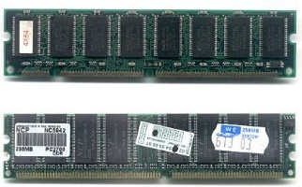

**DAUGHTR CARD:**

A daughterboard (or *daughter board* , *daughter card* , or *daughtercard* ) is a circuit board that plugs into and extends the circuitry of another circuit board. The other circuit board may be the computer's main board (its motherboard ) or it may be another board or card that is already in the computer, often a sound card. The term is commonly used by manufacturers of wavetable daughterboards that attach existing sound cards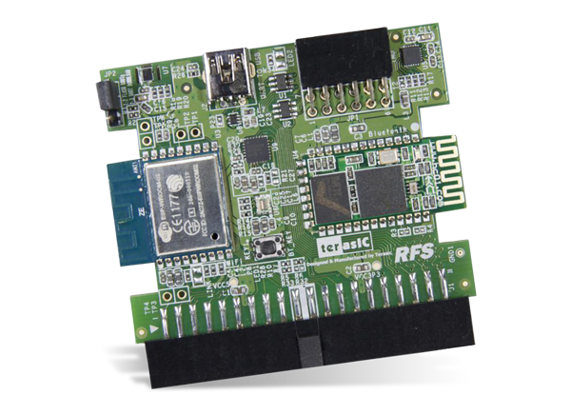.

**BUS SLOTS:**

Alternatively known as a **bus slot** or **expansion port**, an **expansion slot** is a connection or port inside a [computer](https://www.computerhope.com/jargon/c/computer.htm) on the [motherboard](https://www.computerhope.com/jargon/m/mothboar.htm) or [riser card](https://www.computerhope.com/jargon/r/risecard.htm). It provides an installation point for a hardware expansion card to be connected.

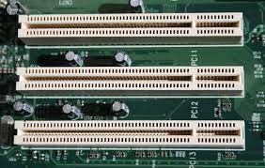

**SMPS:**

A switched-mode power supply (SMPS) is an electronic circuit that converts power using switching devices that are turned on and off at high frequencies, and storage components such as inductors or capacitors to supply power when the switching device is in its non-conduction state

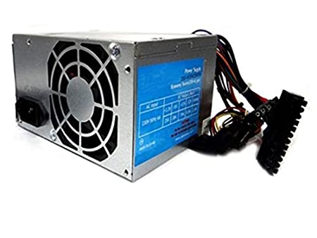

**STORAGE DEVICES :**

There are two types of storage device used as secondary storage in computers: HDD and SSD. While HDDs are the more traditional of the two, SSDs are fast overtaking HDD as the preferred tech for secondary storage.

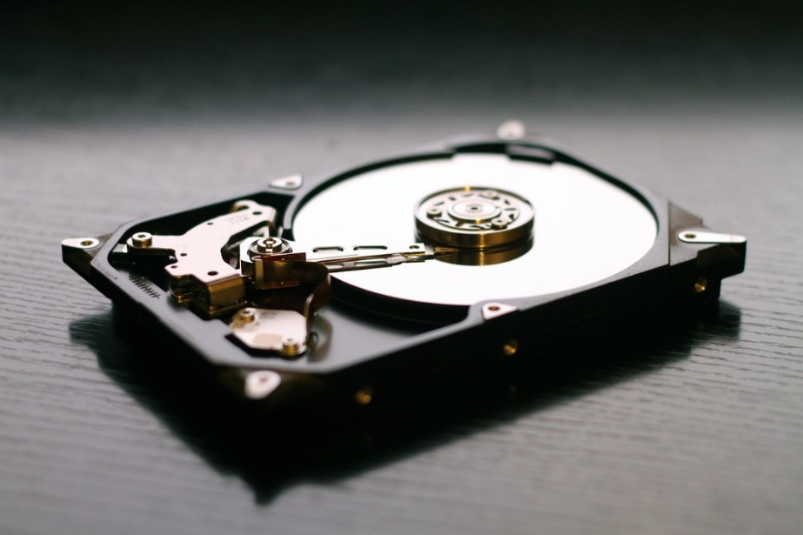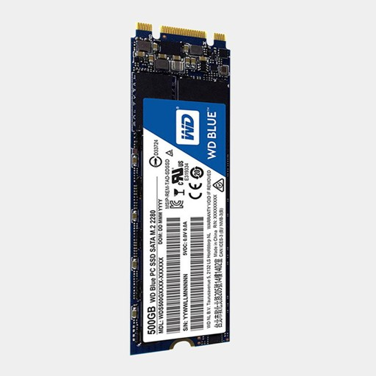

**PORTS**:

A Computer Port is an interface or a point of connection between the computer and its peripheral devices. Some of the common peripherals are mouse, keyboard, monitor or display unit, printer, speaker, flash drive etc.

The main function of a computer port is to act as a point of attachment, where the cable from the peripheral can be plugged in and allows data to flow from and to the device.

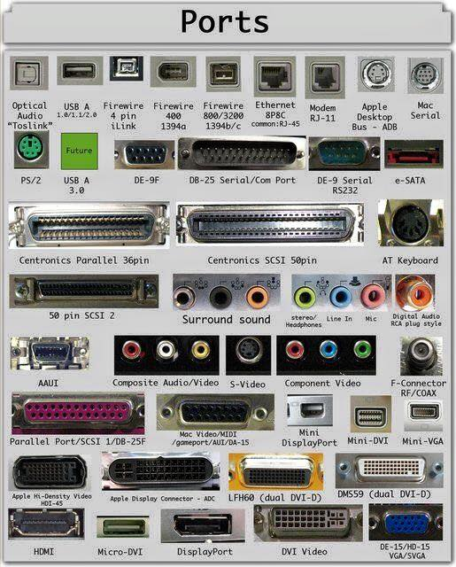

**SPECIFICATION OF DESKTOP AND SERVER CLASS CMPUTERS:**

|  |  |
| --- | --- |
| Component | Specification |
| Processor: | 10th or 11th Gen Intel Core i5, i7 or i9 Processor, or Apple M1 Processor (CPU) |
| Operating System: | Microsoft Windows 10 Home, Pro, Enterprise or Education version *or* macOS 10.15.X “Catalina” or 11.X “Big Sur.” |
| Memory (RAM): | 8-16 GB of RAM |
| Storage: | 240 GB solid state drive, or larger. |
| Video/Graphics: | Integrated or Discrete graphics processor capable of 1440 X 900 resolution, or better (1920 X 1080 *or* 1200 ideal). |
| Monitor: | for notebook: 13″ – 17″ display for desktop: 19″ – 27″ widescreen flat-panel display |
| Mouse: | Built-in or external trackpad, wireless and/or USB, 2-button, optical mouse |
| Sound: | Sound card or built-in audio, and speakers |
| Headphones: | Headphones or Earbuds, with Built-in Microphone |
| Webcam: | Either external USB device or built-in |
| Network: | 802.11ac Wi-Fi capability. |

*Intel i5 & i7*

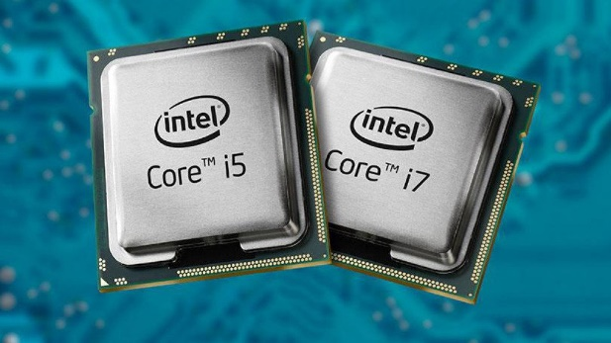

*Ryzen*

